DBMS SQL Lab 5 – Creating and Modifying Tables

In this Lab you will carry out the following:
- Create a table
- Insert a Row onto the table
- Create a View
- Update a field
- Alter the structure of the table
- Delete rows in the table
- Remove the complete table

- Create a table called member which has the following columns
cust_no which should be an identity column
first_name
last_name
address which should allow null values
phone which should allow null values
shop_no an integer
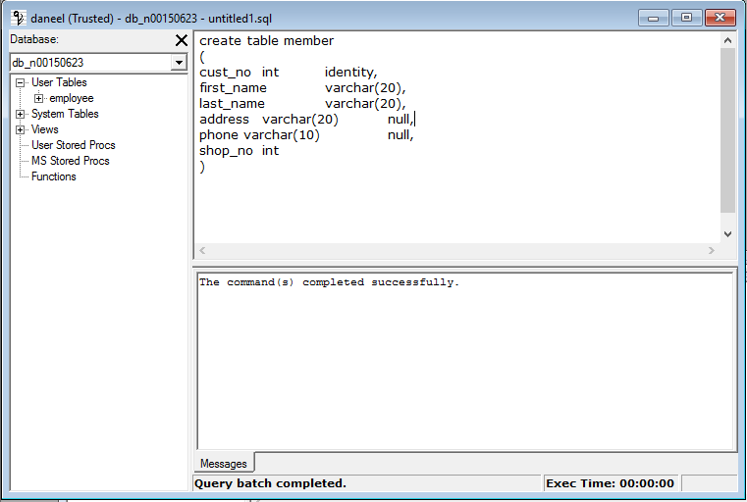

- Enter a row of data for the following customer:
James Murphy from Dublin whose phone is 0871234567 and uses shop 3

- Insert another 3 rows of data into the table, 2 of which must be from Dublin.
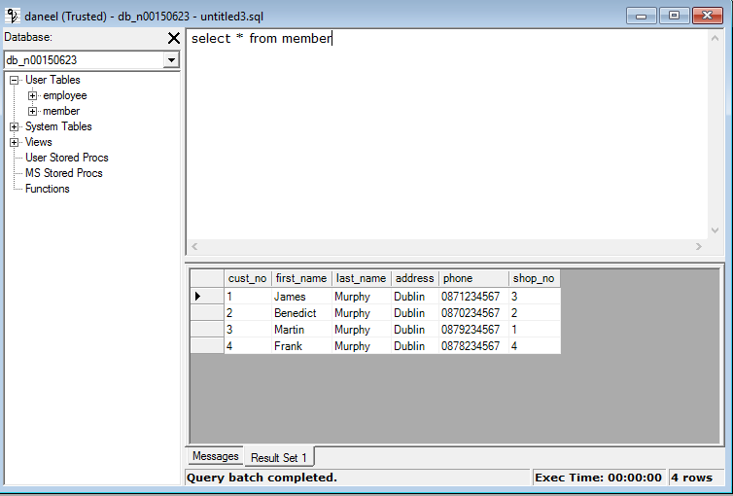

- Create a view to display only those customers who are from Dublin.
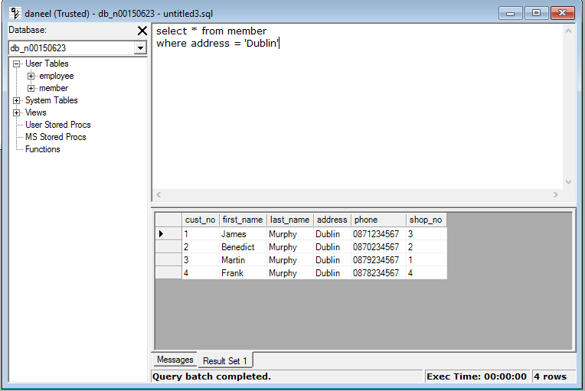

- Change James to Jimmy in the table
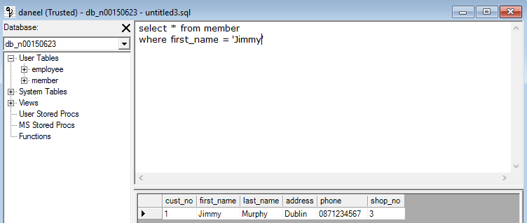

- Get rid of the phone column
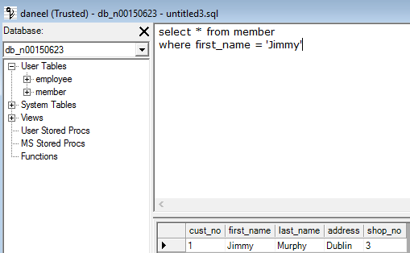

- Add a phone_no column which is a varchar type
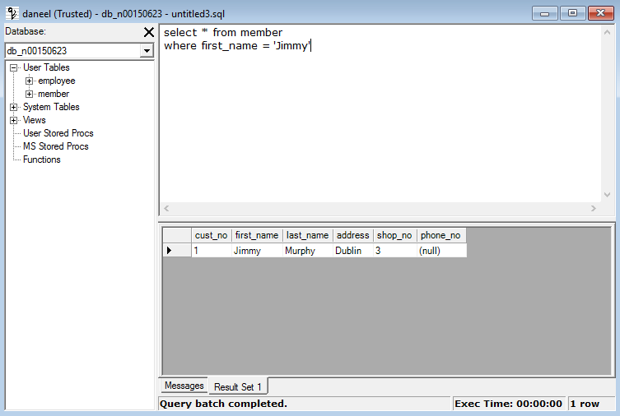

- Get rid of customer whose customer number is 2.
